CIS 9440 UTA - Data Warehousing
Final Group Project
Education-related complaints analysis of NYC
Group 15

Xiaolin Wu
Xiaolin.WU1@baruchmail.cuny.edu
Evelyn Zhu
EVELYN.ZHU@baruchmail.cuny.edu
William Preston Leslie II
WILLIAM.LESLIEII56@baruchmail.cuny.edu
Mariana Futuro
marianabetriz.futurodelima@baruchmail.cuny.edu
Spring 2026 | Baruch College, CUNY

Section 1: Introduction
Our project analyzes school-related operational concerns in New York City by integrating two public NYC Open Data sources: NYC 311 service requests related to DOE and DOHMH agencies, and DOHMH school cafeteria inspection records. The purpose of the project is exploratory rather than causal. We wanted to understand where school-related complaints are concentrated, which complaint categories appear most often, how complaint activity changes over time, and whether boroughs with higher public complaint activity also show higher cafeteria inspection activity or more violation-related records. Because the project evolved across the semester, our final analysis focuses on patterns that could be compared reliably across the two data marts, especially by borough, time period, complaint category, inspection activity, and violation-related outcomes.
Our two main analytics questions are:
- AQ1: How are school-related NYC 311 complaints distributed across boroughs, complaint categories, and time periods?
- AQ2: How do school-related 311 complaint patterns compare with cafeteria inspection activity and violation-related outcomes?
The potential stakeholders for this analysis include NYC Department of Education administrators, DOHMH inspection and public health staff, city officials, school operations teams, and parent or community advocacy groups. We assume that higher complaint volume may point to locations or issue categories that deserve closer review, especially when complaint patterns overlap with inspection activity or violation records. The analysis may help stakeholders prioritize follow-up investigations, compare borough-level patterns, and identify operational concerns such as pest control, food-related complaints, or long response times. The main KPIs we analyzed include total 311 complaints by borough, monthly complaint trends, complaint category distribution, complaints compared with cafeteria inspections, and violation records by borough, and average, minimum, and maximum days to close by complaint type and borough.
Data sources used in this project:
- NYC 311 Service Requests: Event-level 311 service request records filtered to DOE and DOHMH agencies from 2021 onward. The dataset includes complaint type, descriptor, agency, borough, ZIP code, status, created date, and closed date.
Source: https://data.cityofnewyork.us/resource/erm2-nwe9
- DOHMH School Cafeteria Inspections: School cafeteria inspection records from the NYC Department of Health and Mental Hygiene. The dataset includes school name, inspection date, inspection type, violation code, and violation description.
Source: https://data.cityofnewyork.us/resource/5ery -qagt

Section 2: Dimensional Model – Diagram and Notes
Our final dimensional model follows a Kimball-style star schema and reflects the revised model used for the final warehouse and analysis. Earlier milestones included planning-stage drafts, but the final report uses the updated dimensional model because it better matches the tables transformed and used in Milestone 4 and Milestone 5. The model contains two event-level fact tables: fact_311_requests and fact_cafeteria_inspections. These fact tables are connected through conformed dimensions, especially dim_shared_date and dim_shared_geography, which support cross-mart analysis across time and borough/ZIP-level geography.

Figure 1. Final Dimensional Model Used for Analysis
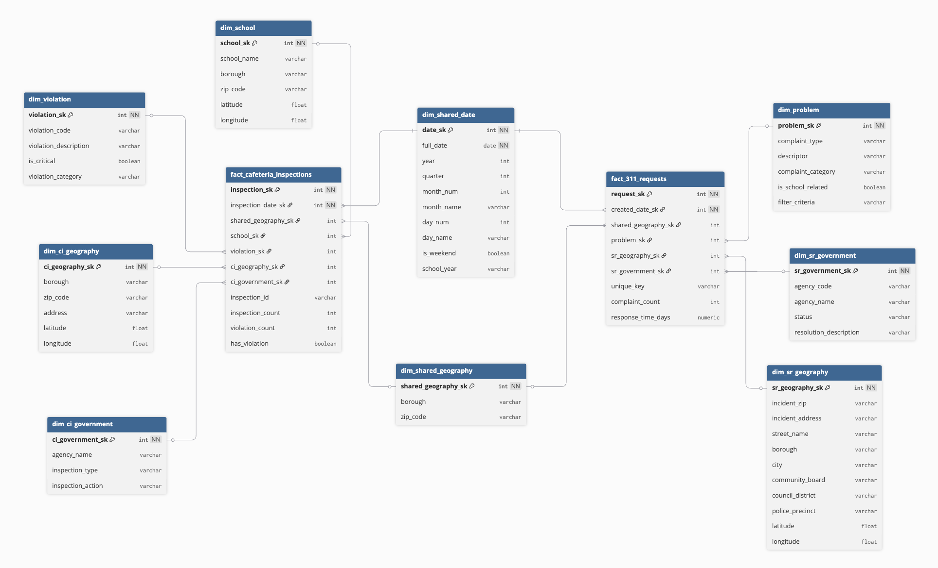
The model includes two fact tables:
- Fact_311_requests
Grain: one row per school-related 311 service request or complaint event.
This fact table supports complaint volume analysis, complaint category analysis, borough distribution, monthly trend analysis, and response-time metrics.
- Fact_cafeteria_inspections
Grain: one row per cafeteria inspection event at a school on an inspection date.
This fact table supports inspection activity analysis and violation-related metrics.
The model includes two main conformed dimensions shared across both marts:
- dim_shared_date supports analysis by date, month, year, and school-year-related time periods.
- dim_shared_geography supports cross-mart comparison by shared geographic fields such as borough and ZIP code.
The 311 complaint mart also includes mart-specific dimensions: dim_problem, dim_sr_geography, and dim_sr_government. These dimensions store complaint type, descriptor, complaint category, agency information, status, resolution description, and detailed 311 location attributes. The cafeteria inspection mart includes mart-specific dimensions: dim_school, dim_violation, dim_ci_geography, and dim_ci_government. These dimensions store school information, violation code and description, inspection-side geography, inspection type, and agency-related fields. Violation fields are nullable because not every inspection record includes a violation.
Several modeling decisions were made during transformation. Surrogate keys were used to make joins more stable and to reduce dependence on source-system values. Date fields were modeled at the date level rather than the full datetime level to avoid unnecessary high cardinality. ZIP code fields were preserved as strings so that leading zeros would not be lost. Standard BigQuery data types were used throughout the model: integer fields for surrogate keys and counts, date fields for time attributes, string fields for descriptive attributes, numeric or floating-point fields for latitude and longitude, and boolean-style fields for violation indicators.
One major modeling challenge was school-level matching. The cafeteria inspection dataset contains school names, but the 311 service request data does not provide a reliable standardized school identifier that can consistently connect each complaint to a specific school. Because of this, the final cross-mart analysis connects the two marts mainly through shared date and shared geography rather than making school-level causal claims. This is why the dashboard compares complaint counts, inspection records, and violation records mainly at the borough level. This approach keeps the final analysis aligned with what the implemented warehouse can support reliably.

Section 3: Data Processing & Technical Architecture Description
Our project used an ELT pipeline to move data from NYC Open Data into Google BigQuery and then transform it into a final dimensional warehouse for analysis. The two source datasets were NYC 311 service requests filtered to DOE and DOHMH agencies from 2021 onward, and DOHMH school cafeteria inspection records. Google Cloud Run and Python scripts were used to extract data from the Socrata API and load it into BigQuery raw tables. Cloud Scheduler supported automated loading, while dbt Cloud was used for the transformation layer. This workflow follows the course model of raw → staging → final warehouse/marts, rather than transforming directly from raw data into final analysis tables.

Figure 2. dbt Lineage Graph Showing Raw, Staging, Dimension, and Fact Models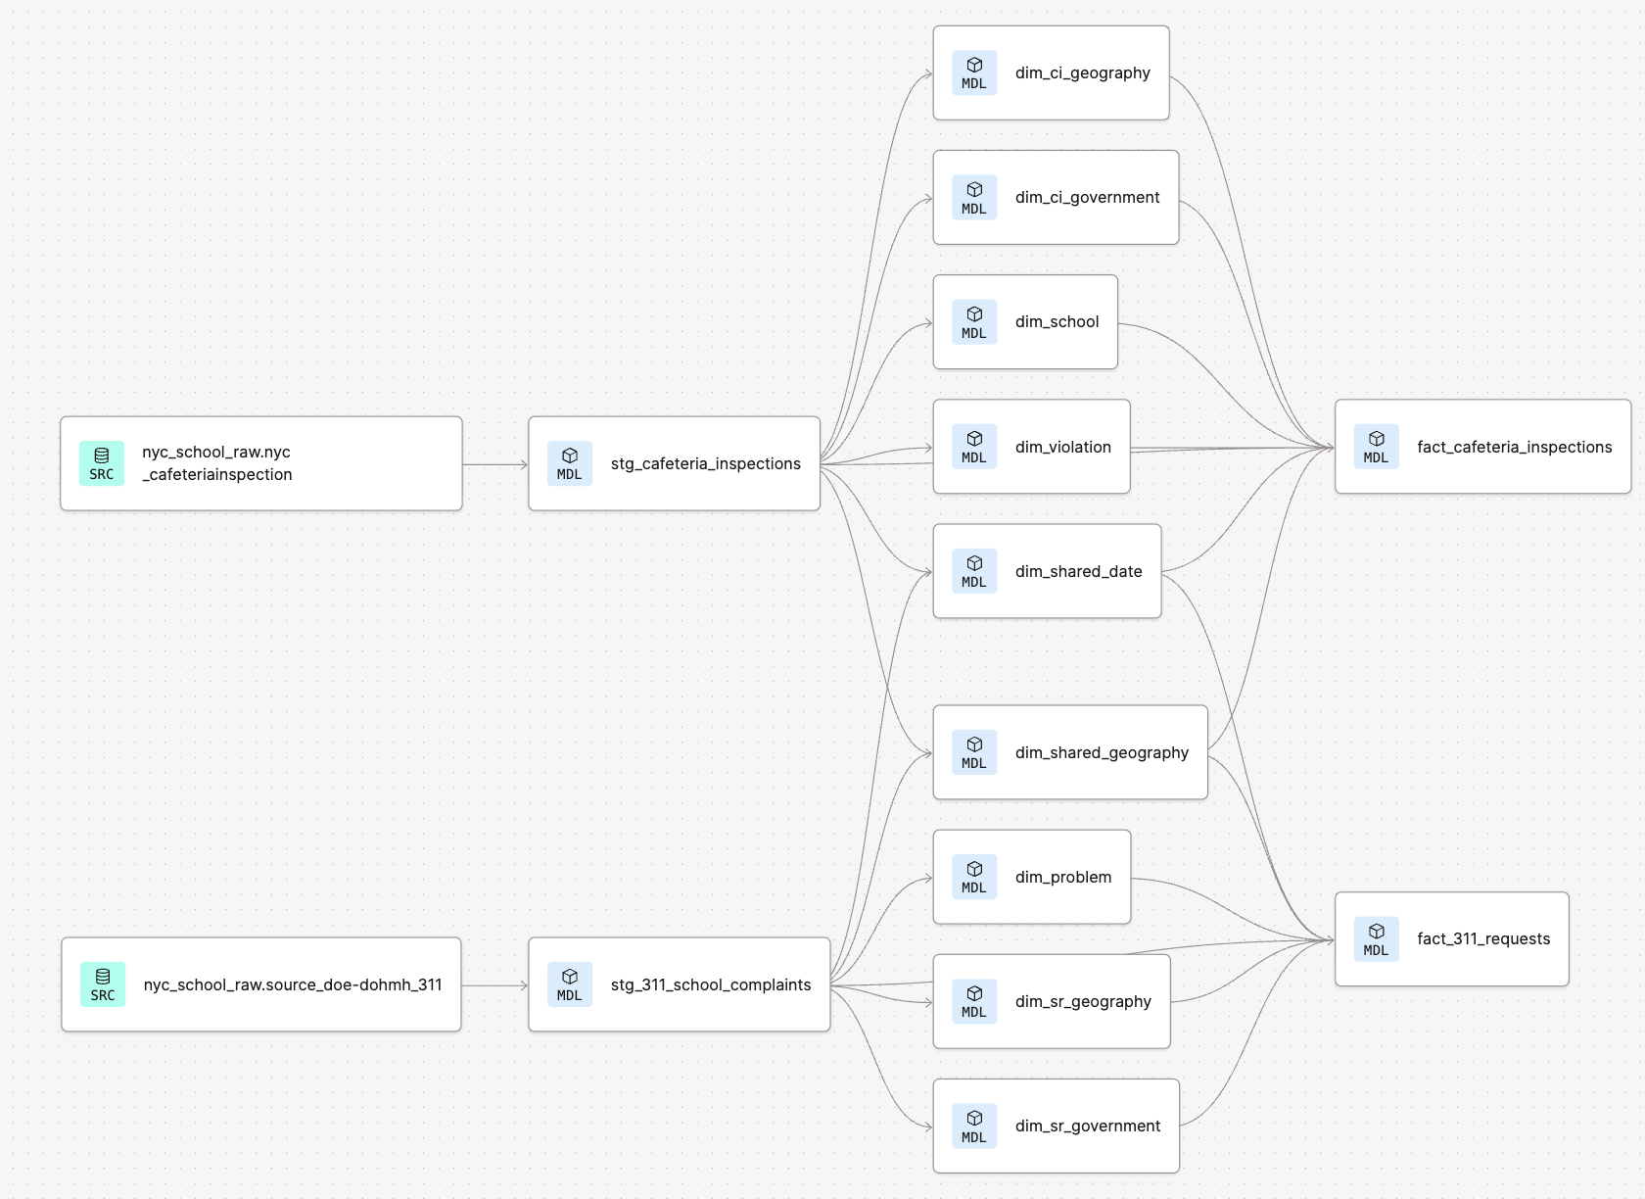

Stage | BigQuery Dataset | Purpose | Main Tables
Raw | nyc_school_raw | Stores source data loaded from NYC Open Data with minimal changes. | source_service_request, source_cafeteria_inspections
Staging | nyc_school_staging | Cleans and standardizes raw data before dimensional modeling. | stg_nyc_311_doedohmh, stg_cafeteria_inspections
Marts / Warehouse | nyc_school_marts | Stores the final Kimball-style star schema used for analysis. | fact_311_requests, fact_cafeteria_inspections, dim_shared_date, dim_shared_geography, dim_problem, dim_sr_government, dim_sr_geography, dim_school, dim_violation, dim_ci_geography, dim_ci_government

In the staging layer, we standardized borough values, preserved ZIP codes as strings, cleaned text fields, converted empty strings to NULL values, parsed date and timestamp fields, and removed duplicate records where needed. In the marts layer, dbt models created shared dimensions, mart-specific dimensions, and fact tables. Surrogate keys were generated with dbt_utils.generate_surrogate_key, and fact tables were joined to dimension tables through dbt ref() dependencies. The final warehouse supports monthly complaint trends, borough-level complaint comparisons, response-time analysis, cafeteria inspection activity, violation-related analysis, and cross-mart comparison through shared date and shared geography dimensions.
The full dbt project code, including SQL model files, dbt_project.yml, sources.yml, and packages.yml, is available in the project GitHub repository: [insert GitHub repository hyperlink here]. BigQuery access was shared with the professor for the raw, staging, and marts datasets. For Milestone 5, we also created dashboard analysis tables from the warehouse tables, including complaint counts by borough, monthly complaint trends, complaint category distribution, complaint and inspection comparison by borough, and response-time metrics.

Section 4: Analysis and Visualization Summary

Our BI dashboard was created in Looker Studio using analysis tables built from the BigQuery warehouse. The dashboard focuses on answering our two analytics questions by showing where school-related 311 complaint activity is concentrated, how complaint volume changes over time, which complaint categories appear most often, and how complaint patterns compare with cafeteria inspection and violation-related records at the borough level.

Live dashboard link (shared with jaclyn.cohen@baruch.cuny.edu): https://datastudio.google.com/reporting/af082ad1-36a9-452a-b6fd-66b5a8803dcc/page/f6lxF

Figure 3. BI Dashboard Overview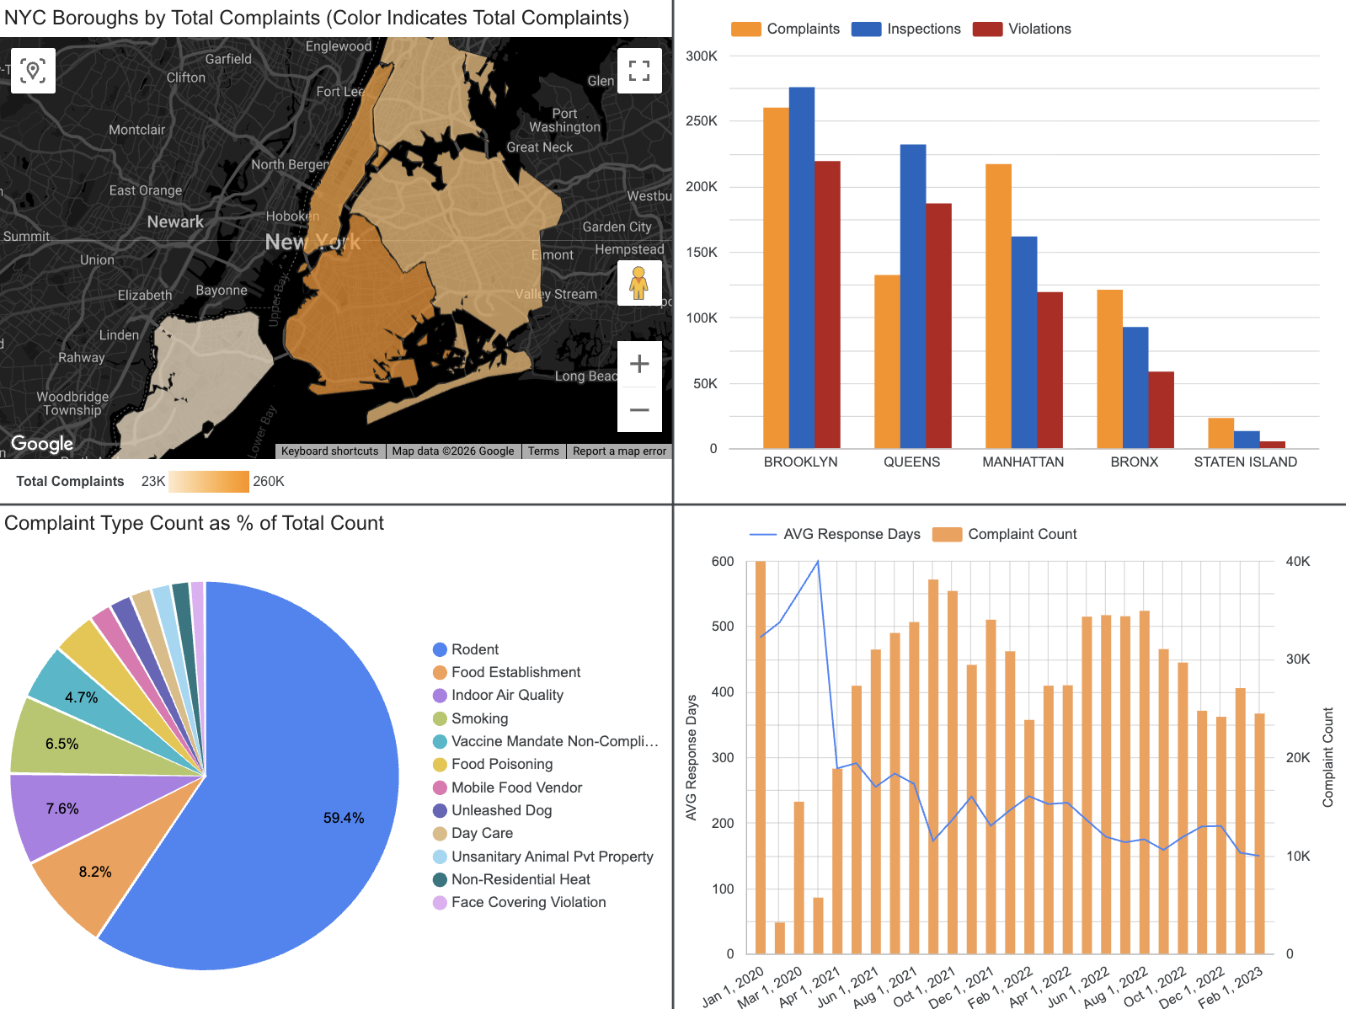
Figure 4. Response Time Detail Table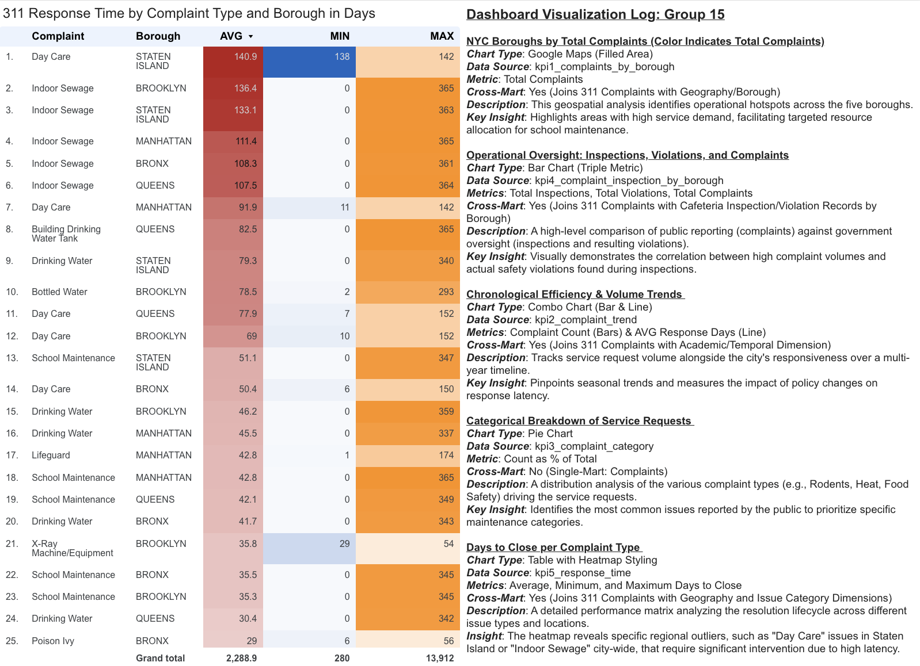

Visualization | Dashboard Data Source | Description
NYC Boroughs by Total Complaints | kpi1_complaints_by_borough | A filled map focused on New York City, showing total school-related 311 complaint volume by borough. This helps identify geographic areas with higher public complaint activity.
Operational Oversight: Inspections, Violations, and Complaints | kpi4_complaint_inspection_by_borough | A bar chart comparing total complaints, cafeteria inspection records, and violation records by borough. This is the main cross-mart visualization because it uses both 311 complaint data and cafeteria inspection data.
Chronological Efficiency & Volume Trends | kpi2_complaint_trend | A combo chart showing monthly complaint count and average response days. This helps compare complaint volume with response-time patterns over time.
Categorical Breakdown of Service Requests | kpi3_complaint_category | A pie chart showing the share of major complaint types. This helps identify which school-related complaint categories appear most often in the 311 data.
Days to Close by Complaint Type and Borough | kpi5_response_time | A table showing average, minimum, and maximum days to close by complaint type and borough. This helps identify complaint categories and locations with longer resolution times.

Overall, the dashboard shows that school-related 311 complaint activity is not evenly distributed across boroughs. The borough map and bar chart make it easier to compare complaint concentration across New York City, while the complaint category chart shows that rodent-related complaints make up the largest share of reported issues, followed by categories such as food establishment, indoor air quality, and smoking. The monthly trend chart shows that complaint volume changes over time and that average response days vary across months, suggesting that both service demand and resolution time should be reviewed together rather than separately.

The cross-mart borough comparison shows how 311 complaint activity relates to cafeteria inspection activity and violation records at a broad geographic level. This does not prove that complaints cause inspection outcomes, but it helps identify borough-level patterns where public complaint volume and inspection/violation records can be reviewed side by side. The response-time table adds a service-efficiency perspective by showing which complaint types and boroughs have longer days-to-close values. Together, these visualizations support the project’s exploratory goal: identifying patterns in school-related operational concerns and highlighting areas that may deserve closer follow-up review.

Section 5: Narrative Conclusion and Results

Our analysis shows that school-related 311 complaint activity is unevenly distributed across New York City and that complaint patterns vary by borough, time period, and issue category. Brooklyn, Manhattan, and Queens show higher complaint volumes than the Bronx and Staten Island, while rodent-related complaints make up the largest share of the complaint categories in our dashboard. The monthly trend visualization also shows that complaint volume and average response time do not always move in the same direction, which suggests that service demand and resolution efficiency should be reviewed together. For stakeholders such as DOE operations teams, DOHMH inspection staff, and city officials, these results may help identify boroughs and issue categories that deserve closer review, especially when complaint volume is high or response times are unusually long.

The cross-mart analysis compares 311 complaint activity with cafeteria inspection records and violation-related records at the borough level. This comparison does not prove that 311 complaints cause more inspections or more violations, but it provides a useful way to review public complaint patterns alongside government inspection activity. Based on the final model, the strongest recommendation is to use this dashboard as an exploratory monitoring tool rather than a causal evaluation tool. Areas with both high complaint activity and high inspection or violation records may deserve additional follow-up, while areas with long days-to-close values may need further review of operational response processes. A major limitation is that the 311 dataset does not provide a reliable standardized school identifier that can consistently connect each complaint to an individual school, so our final cross-mart analysis is strongest at the borough and ZIP-code level rather than the school level. Future analysis could improve this work by adding standardized school identifiers, enrollment data, or school-level facility information to support more detailed comparisons.

Section 6: References
Original Data Sources
- Original Data Sources
NYC 311 Service Requests from 2020 to Present
Curator: NYC Open Data / City of New York
Source link: NYC 311 Service Requests
Accessed: May 2026
Use in project: Source dataset for school-related 311 service request records, filtered to DOE and DOHMH agencies from 2021 onward.
- DOHMH School Cafeteria Inspections 2020–Present
Curator: NYC Department of Health and Mental Hygiene / NYC Open Data
Source link: DOHMH School Cafeteria Inspections
Accessed: May 2026
Use in project: Source dataset for school cafeteria inspection records, including inspection activity and violation-related fields.
Project Code, Warehouse, and Analysis Outputs
- Project GitHub Repository
Resource link: CIS9440 Analytics Project GitHub Repository
Accessed: May 2026
Use in project: Stores dbt project files, SQL models, dbt_project.yml, sources.yml, and packages.yml. The project documentation notes that the dbt project code was stored in GitHub and used for version control.
- Google BigQuery Warehouse Datasets
Resource: Google BigQuery shared datasets
Access: Shared with jaclyn.cohen@baruch.cuny.edu
Use in project: Stores the raw, staging, and marts datasets used for the final warehouse. The main datasets are:
- nyc_school_raw
- nyc_school_staging
- nyc_school_marts
- Final Warehouse Tables in BigQuery
Resource: BigQuery tables in nyc_school_marts
Access: Shared with jaclyn.cohen@baruch.cuny.edu
Use in project: Final star-schema warehouse tables used for analysis:
- fact_311_requests
- fact_cafeteria_inspections
- dim_shared_date
- dim_shared_geography
- dim_problem
- dim_sr_government
- dim_sr_geography
- dim_school
- dim_violation
- dim_ci_geography
- dim_ci_government
- Dashboard Analysis Tables in BigQuery
Resource: BigQuery analysis tables used for Looker Studio dashboard
Access: Shared with jaclyn.cohen@baruch.cuny.edu
Use in project: Analysis tables created from the warehouse tables for dashboard visualizations:
- kpi1_complaints_by_borough
- kpi2_complaint_trend
- kpi3_complaint_category
- kpi4_complaint_inspection_by_borough
- kpi5_response_time
- Looker Studio Dashboard
Resource link: Group 15 Looker Studio Dashboard
Access: Shared with jaclyn.cohen@baruch.cuny.edu
Use in project: Final BI dashboard for visualizing complaint distribution, monthly trends, complaint categories, cross-mart borough comparison, and response-time metrics. Milestone 5 identifies these five KPI areas as the dashboard’s main analysis outputs.

Software and Tools Used
- Google BigQuery — used as the cloud data warehouse.
- Google Cloud Run — used to run Python extraction/loading services.
- Google Cloud Scheduler — used to trigger automated data loading.
- dbt Cloud — used to transform raw data into staging models, dimensions, and fact tables.
- dbt_utils — used to generate surrogate keys.
- Python / Socrata API / sodapy / google-cloud-bigquery — used for data extraction and loading.
- Looker Studio — used to build the BI dashboard.
- GitHub — used for project code storage and version control.

